
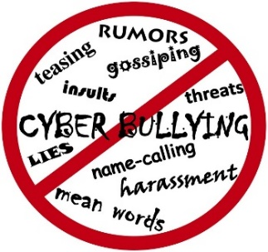
Ysgol Tanyfron
Our Anti-Bullying Policy


When is it bullying?
Several
Times
On
Purpose

We promise to ALWAYS treat bullying seriously. You have the right to feel safe, secure and happy at Tanyfron.
Who can I tell?
• A Friend
• Parent/Guardian
• Teachers
• Lunch time Staff
• Anyone you feel you can trust
Our teachers and pupils have always got time to listen!
What is Bullying?
At our school we will not tolerate bullying, we are one big family. We believe a bully is someone who hurts someone more than once, by using behaviour which is meant to hurt, frighten or threaten another person.
Tell them to stop if you can, walk away or tell somebody. Don’t retaliate, don’t believe what they say or feel it is your fault.

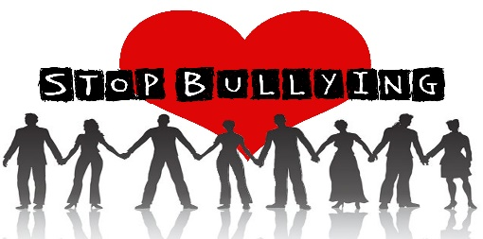



This Photo by Unknown Author is licensed under CC BY-NC-ND
Bullying can be……
Emotional: Hurting people’s feelings, leaving you out.
Physical: Punching, kicking, spitting, hitting, pushing.
Verbal: Being teased, name calling, unkind words.
Racist: Calling you racist names. Cyber: Saying unkind things by text, e-mail and social media.
What is cyber bullying?
When someone is mean to you online via social media, you might not know them, but they persist to do unkind things.
Cyber bullying is hurtful please speak out!
Start Telling Other People!!

