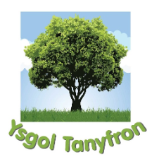
Ysgol Tanyfron

Child Protection
Policy

Date reviewed and updated: | November 2024
Signed By Chair of Governors:

Signed By Headteacher: | 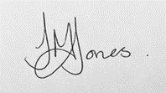
Date Approved: | 5.11.24
Document to be next reviewed: | November 2026

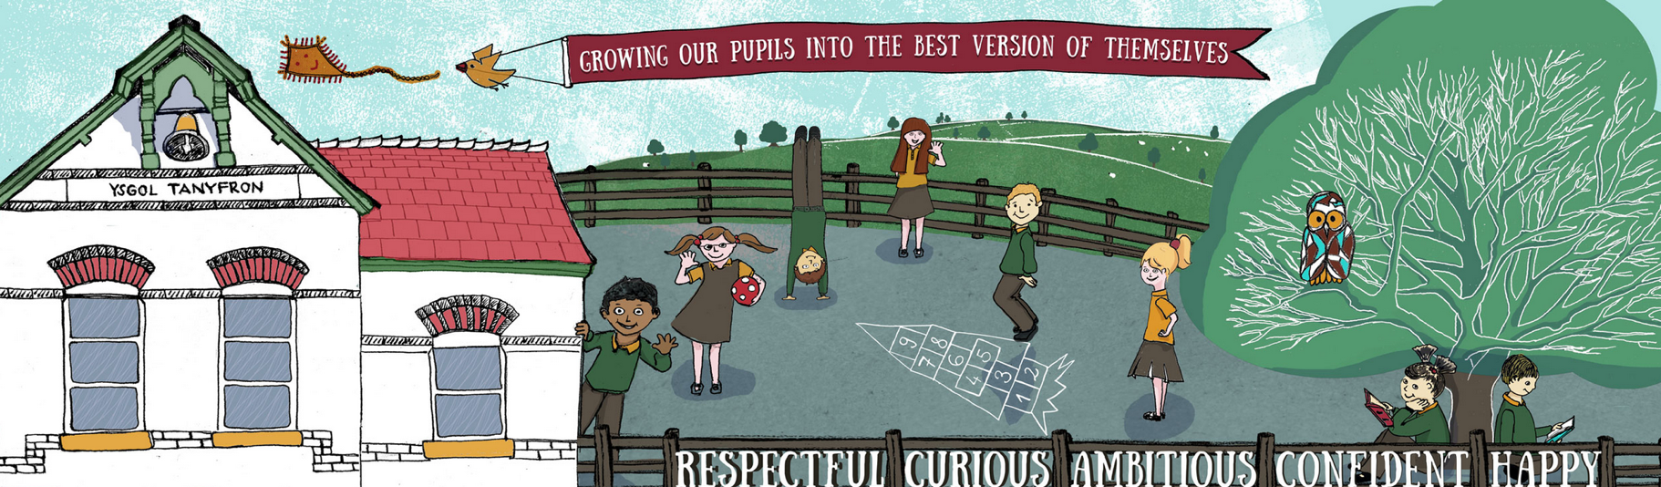

Child Protection Policy

School’s full address and postcode:
Ysgol Tanyfron Primary School, Tanyfron Road, Tanyfron, Wrexham, LL11 5SA

School’s phone number (including area code):
01978 758118

School’s email address:
mailbox@tanyfron-pri.wrexham.sch.uk

Website address for this policy:
www.ysgoltanyfron.co.uk

Person responsible for maintaining this policy: Headteacher

Child Protection Policy

We would wish to create in Ysgol Tanyfron a happy, caring and secure environment where every child is valued and where teachers and parents/guardians work as partners to enhance the child's personal, social, spiritual and educational development. We would hope to encourage the children to become responsible, caring members of society.

Within this framework, a major objective must be to safeguard and promote the welfare of the children in our care. We do this through our pastoral role. One aspect of this role concerns the awareness of all forms of child abuse. Our priority must be the children's welfare. A referral to Social Services may be made on suspicion of abuse and although the suspicion may prove to be groundless, we hope we can still work together for the benefit of the child.

Any teaching or non-teaching member of staff receiving information about abuse or having concerns about a pupil will pass that information on to the Headteacher who is the designated person. If the concern is about the Head Teacher they should contact Mrs Rebecca Phillips, LA Child Protection Officer.

Designated Person – Mrs Carly Harris, Acting Head Teacher
Deputy Designated Person – Mrs Joanne Evans-Jones, Senior Teacher
Deputy Designated Person – Mrs Tara Humberstone, Class Teacher
Designated Governor – Mr Simon Wynne

Role of Designated Person
- To make referrals of all cases of suspected child abuse to the relevant Social Services team.
- To ensure that all staff report any suspicion of child abuse to the designated person.
- To attend INSET for child abuse awareness and recognition and when appropriate, prevention work.
- To ensure that all staff have a knowledge of Wrexham local authority procedures.
- To broaden consultation and decide what action should be taken by a member of staff.
- To liaise with other agencies and attend case conferences.
- To inform the Principal Education Welfare Officer.
- To ensure that ongoing monitoring exists for the pupils having been the subject of child abuse or suspected child abuse.

The designated person will broaden the consultation process and decide what action should be taken. Social Services will be informed, as will the Principal Education Welfare Officer if a referral is to be made.

It is important to realise that a pupil must not be told that information is totally confidential since it has to be disclosed for help to be sought. Nevertheless, the information may be of a sensitive nature and this information may only be shared on a need-to-know basis, however, child protection supersedes confidentiality.

All information concerning child protection should be kept with the designated person. Disclosures should be recorded manually and dated.

Responding To Disclosure
- Listen carefully to what the child is saying.
- Take seriously what the child is saying.
- Write down as soon as possible exactly what the child said.
- Tell your Designated Person as soon as possible
- Make sure the child is safe i.e. supported in school.
- Do tell the child it is not their fault.
- Do not panic.
- Do not immediately rush off to find someone else to listen.
- Do not promise to keep secrets.
- Keep child informed of any action you are preparing to take where appropriate.
- Do not make judgements or say anything about the alleged abuser.
- Do not ask detailed questions or press the child for more information.
- Try not to display any sign of shock or disapproval when the child is making a disclosure.
- The child may not regard the experience as bad or painful, they may not feel guilty or angry.
- Be aware of your own feelings, which may be different from those of the child.
- Take care of yourself by making sure that you have an opportunity to discuss your feelings with someone at a later stage
- Do not destroy any evidence, as it may be useful in a court of law.
- Initial disclosure, even if retracted, still must be referred.

Our procedure complements “The All Wales Child Protection Procedures 2008” as well as Wrexham Guidelines for the Educational Service.

Types of Abuse

Abuse of a child can take many forms and are categorised into four areas
- Physical Abuse
- Sexual Abuse
- Emotional Abuse
- Neglect

DEFINITIONS

Significant Harm
Under s31(9) of the Children Act 1989:
Harm means physical, intellectual, emotional, social or behavioural development;
Health means physical or mental health; and
Ill treatment includes sexual abuse and forms of ill treatment which are not physical.

Under s31(10) of the Act:
Where the question of whether the harm suffered by a child is significant turns on the child’s health and development, his health or development shall be compared with that which could reasonably be expected of a similar child.
(working together 2008)

Physical Abuse
Physical abuse may involve hitting, shaking, throwing, poisoning, burning or scalding, drowning, suffocating, or otherwise causing physical harm to a child. Physical harm can also be caused when a parent or carer feigns the symptoms of, or deliberately causes ill health in and to a child whom they are looking after. (The situation is most recently described using the term fabricated or induced illness by a carer).

Emotional Abuse
Emotional abuse is the persistent emotional ill treatment of a child such as to cause severe and persistent adverse effects on the child’s emotional development. It may involve conveying to a child that they are worthless or unloved, inadequate or valued only in so far as they meet the needs of another person. It may feature age or developmentally inappropriate expectations being imposed on children. It may involve causing children frequently to feel frightened or in danger, or the exploitation or corruption of children. Some level of emotional abuse is involved in all types of ill treatment of a child, though it may occur alone.

Sexual Abuse
Sexual abuse involves forcing or enticing a child or young person to take part in sexual activities, whether or not the child is aware of what is happening. The activities may involve physical contact, including penetrative or non-penetrative acts. They may include non-contact activities, such as involving children in looking at, or in the production of, pornographic material or watching sexual activities, or encouraging children to behave in sexually inappropriate ways.

Neglect
Neglect is the persistent failure to meet a child’s basic physical and/or psychological needs, likely to result in the serious impairment of the child’s health or development. It may involve a parent or carer failing to provide adequate food, shelter and clothing, failing to protect a child from physical harm or danger, or the failure to ensure access to appropriate medical care or treatment. It may also include neglect or, or unresponsiveness to, a child’s basic emotional needs.

If there is any doubt then the concern should be progressed.

Training of Staff and Governors
- Staff will all attend the Level 2 child protection training at county courses or the Education Welfare Officer will provide in-house training for larger numbers of staff.
- The designated person along with key members of the teaching staff will have completed Level 3 training with the local authority.
- Governors will be trained as appropriate at Governor sub-group meetings.

