
Ysgol Tanyfron

Assessment
Policy

Date reviewed and updated: | March 2026
Signed By Chair of Governors:

Signed By Headteacher: | 
Date Approved: | March 2026
Document to be next reviewed: | Spring 2027

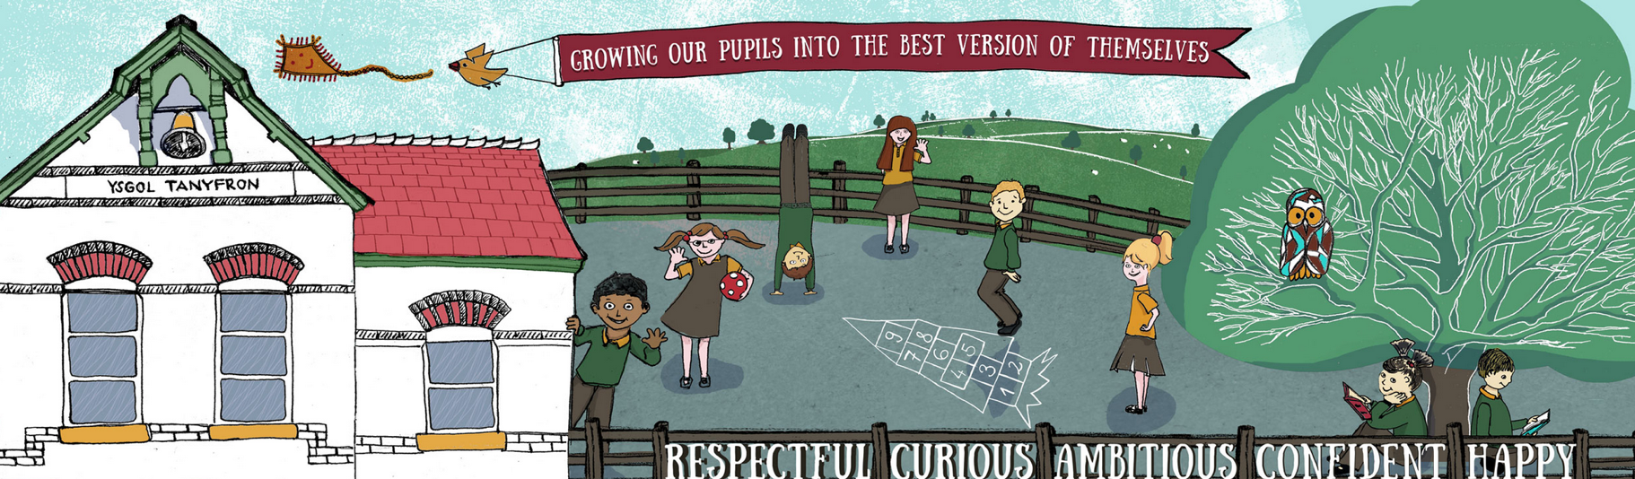

Assessment, Recording & Reporting Policy

Introduction
This policy reflects the values and philosophy of Ysgol Tanyfron in relation to assessment. It gives a framework to which staff work and gives guidance on how, when and why we assess the work of pupils. This policy also sets out how assessment across the school will be monitored and evidenced.

Assessment at Ysgol Tanyfron.
At Ysgol Tanyfron we believe that good assessment is fundamental to effective teaching and learning. Assessment is central to classroom practice; it is the process of making judgements about pupil’s progress in relation to firstly their potential and then within the progression steps of the curriculum. The judgements made by teachers and by the pupils themselves will be used in a continuous process of moving children on to their next stage of learning and will inform the methods of progression. Good assessment aids continuity and progression by enabling teachers to build on pupil’s previous learning experiences by planning for future needs. Good assessment will be used to inform differentiated planning to foster motivation within learners.
Aims
- To make judgements about a pupil’s progress
- To inform future planning
- To identify strengths
- To diagnose weaknesses/areas of development
- To raise standards of progress
- To involve pupils in the learning process by enabling them to judge how well they are doing and what they need to do next
- To raise expectation
- To allow for the celebration of success and to raise self-esteem.
- To establish working levels within the progression steps of the national curriculum
- To inform reports to parents

The Curriculum for Wales guidelines state that there are three purposes to assessment:
Assessment arrangements - Hwb (gov.wales)

- Supporting individual learners on an ongoing, day-to day basis
- Identifying, capturing, and reflecting on individual learner progress over time
- Understanding group progress to reflect on practice

This policy summarises how the school addresses these requirements.

On-entry Assessment
We will collate information from a range of sources during the six a week first when a pupil starts in the school to construct an initial holistic picture and to identify the social, emotional, health and academic needs from:
- Previous setting / school
- Parents
- Health workers
- Other agencies as may be appropriate – for example Social Services
- Classroom observations

We will carry out observations and assessments to identify pupils’ needs which will focus on their literacy and numeracy skills, their social and wellbeing skills, physical skills and any specific medical or learning needs. We will use this information to inform strengths and areas for development.

On-going day to day assessment:
- We will ensure ongoing day-to-day assessment to identify the learner's current achievements and plan the direction for their next stages of learning
- We will provide timely feedback to pupils based on learning outcomes, clear success criteria and effective questioning
- We will ensure opportunities for self-assessment and peer assessment
- We will encourage effective response to feedback from learner and practitioner

Marking and Feedback
- The school utilises marking slips to assess pupil’s work against a set success criteria. These are completed at regular intervals in units of work.
- The following codes will still be used on marking slips. VF – verbal feedback, WS – with support, D – developing, I – independent, . – not achieved to indicate progress against the criteria.
- Feedback and next steps are identified on the marking slip and followed up during D.I.R.T. time.
- Foundation Phase provide verbal feedback against the set success criteria when evidencing work on Seesaw.
- Self-Assessment is taught from KS2 onwards and allows the pupils to assess their own work against the success criteria and document on the marking slip.

Professional Dialogue within a school - focus on progress and general well-being
There will be on-going professional dialogue at least once every half term to discuss pupils progress and to develop a shared understanding of progression. During the meetings, staff will share and discuss pupils' progress and their general wellbeing. This could be during PPA, phase/team meetings and in groups (a mixture of teachers from different year groups) during staff meetings.

We will focus on how to move the learning forward and identifying next steps and/or support for the learners. To facilitate the discussions, we can consider examples of school curriculum and classroom planning, examples of learning and teaching activities and learning – both processes and outcomes as well as examples of additional support provided.

Pupil Progress Meetings
Every term there will be meetings to discuss learners progress and the next steps in their development between teachers and the SLT. We will consider qualitative information – staff observations, pupils work, attitude to learning, pupils and parents input and quantitative data such as Boxall, PASS, online assessments, standardised scores. We will record in a continuous format on the Pupil Progress Tracker.

We will focus on the following:
- Literacy, Language and Communication
- Mathematics and Numeracy
- Health and well being
- Any other AoLEs covered within that term
- Attitude to Learning including attendance
- Pupils’ strengths and interests
- Area for development – academically and well-being
- Any extra support needed and its impact

The school refers to the guidance from learner-well-being-and-assessment-mutual-support-systems.pdf (gov.wales) document during these valuable discussions about pupils.

Sharing information with parents

Developing effective relationships with parents are essential to our assessment procedures. We will:
- Host a parents evening in the 2nd term – this will be to update parents on attitudes to learning, progress and how parents can support at home. Parents will view pupils work to look at the learning journey
- Ensure effective regular and continuous dialogue with parents - sharing learning events through Class Dojo, Google Classroom, Seesaw. Parents will be invited in to ‘Show and Share’ once per term to share the learning process with their child
- Provide a summary report of progress at the end of the year. Parents will be invited to provide feedback

With parents, we will focus on:
- The progress their child is making
- Their future progression needs (next steps)
- How to support the pupil at home
- Their general wellbeing in school

Professional Dialogue between schools
Teachers are given opportunities to meet termly to develop a shared understanding of progression and to discuss how to move the learning forward giving attention to planning and expectations in terms of teaching and learning. To facilitate the discussions, we can consider examples of school curriculum and classroom planning, examples of learning and teaching activities and learning – both processes and outcomes as well as examples of additional support provided.

Transition
As part of transition activities there will meetings termly to engage in professional dialogue - based on the Areas of Learning and Experience / cross-curricular skills to develop a shared understanding of progression. In addition to this it will be an annual transition week for Year 6 pupils, cross school visits for staff and pupils. The Nursery teacher will also host a taster sessions for new starters and will gather important information through observation and from parents.

Involve the learner in the process
We will ensure that the learners get regular input to the process - for example peer and self-assessment and providing evidence of their progress and ensuring opportunities for self-reflection.

Evidencing Progress

Recording
- Progress in work is evidenced through the use of pupil’s books, where each unit of work is assessed against the progression steps and dated to record achievement of learning steps.
- All practical and oral work is evidenced using the digital platform Seesaw.
- Termly measures of progress are documented using the school’s assessment and tracking process which highlights where there are concerns of lack of progress, or where pupils may be identified as more able or talented. This raises discussion to ensure appropriate provision is in place for learners.

Reporting
We believe that it is vitally important to keep parents fully informed of their child/ren’s progress throughout their time with us. We fully conform to all statutory requirements.

Purposes of reporting
Reports are issued to give parents clear information about:
- How their child is performing in relation to potential and the expectations of the school
- How their child is performing in relation to the progression steps within the National curriculum
Reports will also:
- Allow parents to work in partnership with the school in the process of moving children on
- Enable parents to identify strengths and weaknesses
- Create an opportunity for dialogue regarding a child’s progress.

Content of annual reports
- Information about all AOLEs and activities studied at school
- General progress and attitude
- Attendance
- Additional contributions made by a pupil to the life of the school
- Next steps for learning

Other Strategies
In addition to the annual written report:
  - Parents’ evenings are held twice a year in the autumn and spring. These dialogues will focus on children’s progress, next steps for learning and will provide parents with the opportunity to raise concerns etc.
  - Additional meetings are held with parents will be arranged when necessary
  - Annual IDP reviews will be held for pupils with and ALN determination
  - Targeted Universal Provision updates may be given at regular points through the academic year.
  - Home/ School diaries will be used in special circumstances
  - Regular updates of pupil’s progress will be evidenced and provided through the use of the digital platform Seesaw.

