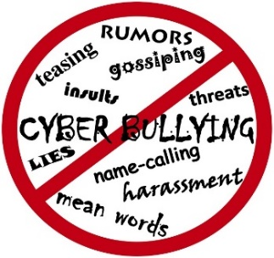

**Ysgol Tanyfron**

**Our Anti-Bullying Policy**

**When is it bullying?**

**S**everal

**T**imes

**O**n

**P**urpose

We promise to ALWAYS treat bullying seriously. You have the right to feel safe, secure and happy at Tanyfron.

**Who can I tell?**

• A Friend

• Parent/Guardian

• Teachers

• Lunch time Staff

• Anyone you feel you can trust

**Our teachers and pupils have always got time to listen!**

**What is Bullying?**

At our school we will not tolerate bullying, we are one big family. We believe a bully is someone who hurts someone more than once, by using behaviour which is meant to hurt, frighten or threaten another person.

Tell them to **stop** if you can, walk away or tell somebody. **Don’t** retaliate, don’t believe what they say or feel it is your fault.

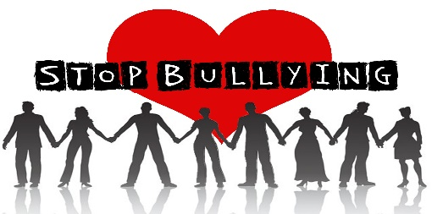

[This Photo](http://selfcarehaven.wordpress.com/2014/08/20/a-culture-of-narcissism-part-ii-cyberbullying-and-trolling) by Unknown Author is licensed under [CC BY-NC-ND](https://creativecommons.org/licenses/by-nc-nd/3.0/)

**Bullying can be……**

**Emotional:** Hurting people’s feelings, leaving you out.

**Physical:** Punching, kicking, spitting, hitting, pushing.

**Verbal:** Being teased, name calling, unkind words.

**Racist:** Calling you racist names. **Cyber:** Saying unkind things by text, e-mail and social media.

**What is cyber bullying?**

When someone is mean to you online via social media, you might not know them, but they persist to do unkind things.

Cyber bullying is hurtful please speak out!

**S**tart **T**elling **O**ther **P**eople!!