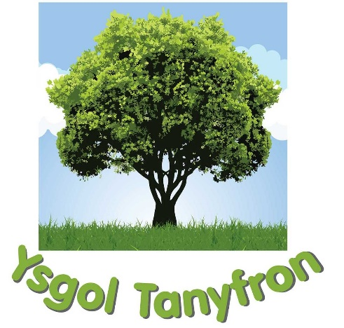
Ysgol Tanyfron
Tanyfron Road, Tanyfron, Southsea, Wrexham LL11 5SA
Ffordd Tanyfron, Tanyfron, Southsea, Wrecsam LL11 5SA

Tel / Ffon: 01978 758118
e-mail: mailbox@tanyfron-pri.wrexham.sch.uk
Headteacher / Pennaeth: Mr D S Lloyd
Chair of Governors: Mr S Wynne

A Parents’ Guide to Anti -Bullying

We would wish to create in Ysgol Tanyfron a happy, caring and secure environment where every child is valued and where teachers and parents/guardians work as partners to enhance the child's personal, social, spiritual and educational development. We would hope to encourage the children to become responsible, caring members of society. However, Ysgol Tanyfron acknowledges that bullying can occur and believes that by establishing an effective anti-bullying policy it can be resolved quickly and successfully, so that both victim and bully can enjoy and fully access all the learning experiences that are provided.

“Children who feel good about themselves are not easy to bully and do not need to bully others”

Types of Bullying?

Verbal Bullying | Physical Bullying
Indirect Bullying | Cyber Bullying

Cyber Bullying is an increasing and more recent problem and is particularly difficult to address. The potential audience for cyberbullying is huge. Several types of cyberbullying have been identified, however the main types are:

Text message | E-mail | Chat-room

What are the most common types of bullying in school?

Making threats | ‘Dirty’ looks | Hair pulling | Hitting | Making someone do something, they do not want to do.
Name calling | Teasing | Kicking | Pushing

- Bullying is repeated and NOT a one off incident.
- It is expected that children fall out with each other and they can sometimes be mean too. We aim to deal with anything that makes your child unhappy so please let us know if there are any problems

Recognising the Signs of Bullying Some signs of bullying may include:

Your child often loses their dinner money. | Your child starts bullying brothers or sisters. | Frightened to say what is wrong. | Your child may not want to go to school. | Clothes or belongings are often damaged.
Coming home hungry. | Your child may be unhappy or unusually quiet. | Unexplained cuts or bruises. | Your child may be sad at bedtime and may cry.

If your child shows any of these signs make, sure you talk together and listen carefully to what is said. It is important that you remain calm, in control, believe your child, and take positive steps to help.

The above signs may not indicate bullying but it does not harm to check!

Remember if you have any worries:

Talk to your child. | Contact your child’s Class Teacher. | Contact the Head teacher.

We aim to offer an open door policy and will always ensure a member of staff is available to chat with you.

For further information and a full copy of our anti bullying policy, please visit our school website – www.ysgoltanyfron.co.uk

