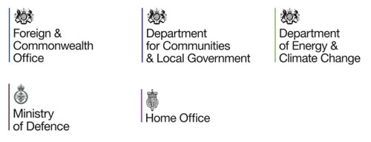

Bronze Challenge

You have been appointed by Her Majesty’s Government to lead the evacuation operation of the residents of Den Frosno ø, before the Glacier collapses with catastrophic consequences!

To be successful and ensure everyone is evacuated safely, you will need to make sure you solve the following problems:

1. You will need to ensure there is enough food for everybody and everyone’s dietary needs are met. There are 100 staff on board and 100 nationals to save (including native Innuits). ½ of the **staff** are either vegetarian or vegan. How many people are vegetarian or vegan?
2. ¾ of the nationals that you are saving are not Innuits. A) How many people are not Innuits? B) How many people are Innuits?
3. It is 34 miles from the harbour to the town and the collapsing glacier is ½ of the distance. How many miles is it to the glacier?
4. It takes 6 hours to travel from the harbour to the town by Husky sledding with all of the equipment needed. It takes 1/3 of the time on a snowmobile. How long does it take on a snowmobile?
5. It takes 3 hours to get to the glacier by Husky sledding with all of the necessary equipment and 1/3 of the time by snowmobile but you can only carry half the amount of equipment. This means you would need to do 2 trips to get all of the equipment to the glacier. Which is fastest to get all of the equipment to the glacier, husky sledding or snowmobile?
6. The equipment weighs 400kg altogether. How much weight can the snowmobile carry if it can hold 50% less?
7. You have been budgeted £100 for food for your 10 day mission. 2/5 of your food budget has been used so far, how many days have you been on your mission so far?
8. Due to the tough climate and long, hard days, you are expected to lose 10% of your body mass. Your current body mass is 60kg. A) How much mass will you lose in Kg? B) What will your mass be after your loss?