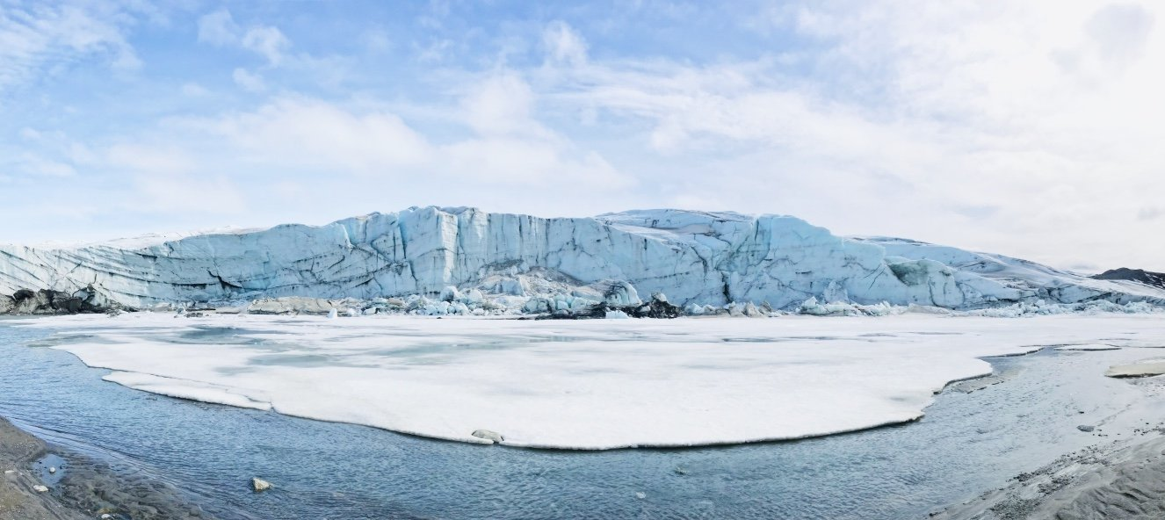
Joe’s Travel Blogs

Popular Posts
Try Thailand: The perfect place to relax
How many countries in the world?
2020: The year of travel and exploration

Recent Comments

Follow Me
Home | About | Destinations | Contact
Exploring Gorgeous Greenland
Where is it?
Greenland is north of Iceland, east of Canada and very much in the Arctic Circle near the North Pole! With almost eighty percent of the land mass covered in snow and ice, it really is the final frontier of tourism, with mass tourism yet to arrive. Greenland only has a population of fifty thousand people across an island that is mostly inhospitable and only accessible by polar expedition!
Thank you for the advice on the Taj Mahal!
How do you get there?
There are no ferries there, not from Denmark, from Iceland or anywhere else in the world. Some super-high-end expedition cruises sometimes take passengers there on a crazy, but wonderful, boat trip through the Arctic circle but costs are often in excess of teen thousand pounds.
Great blog! I want to be a travel blogger too!!
So unless you’re rich, that leaves you with one option – to fly. You can only fly to Greenland from either Iceland or from Denmark (to which Greenland belongs).
Is there anywhere to visit?
One? Probably thousands! But if you visit Greenland for the first time and are on a budget, I believe it would be wise for you to stay in Nuuk.
The capital city of the country offers the perfect combination of nature and wildlife, and history and culture. You can visit the National Museum of Greenland to learn more about the country’s past as a colony of Denmark or the Art Museum of Nuuk to admire some Danish and Greenlandic art.
However, you can also hop on a boat and go whale-watching or on a trip to see icebergs from close up. Alternatively, you can go hiking in the mountains and have a look at the city from above.
Despite the capital city being the main place to stay, you can also fly south to Kangerlussuaq. There you can skip past the lakes, mountains and glaciers and actually get onto the ice cap itself or climb Mount Hassel, which has epic views of the Arctic Desert. I would recommend a trip to the stunning Russell Glacier, which is absolutely breathtaking!
About the Author
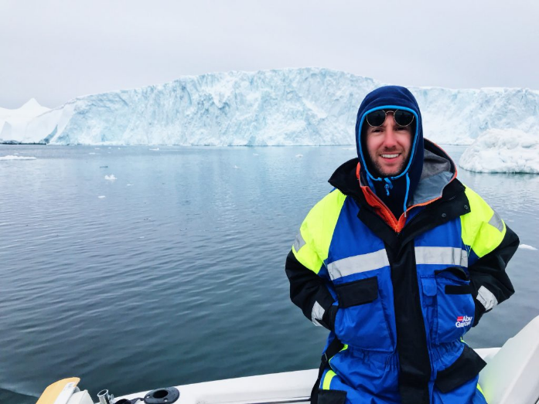
Hello, I’m Joe Bloggs and I’m a professional travel blogger. Ten years ago I left my job as a teacher and began following my dream of seeing the world. I am an advocate of healthy living, enjoying life and savouring every moment. If you want to follow my adventures, then subscribe below!
Subscribe Here!

